Paper Title (16 Bold)

Author (14)
¹ Department of Information and Communication Studies, University of Namibia
² UNESCO, Namibia Office
Corresponding Author: xxxx.(10)

ABSTRACT: (10 Bold) The fourth industrial revolution is here and has ushered in the digital economy which has changed people’s lives and promises ubiquitous ways in which people interact and do business. New media technologies have had severe impact on the print media industry to an extent that journalists and media managers are required to adapt their processes for story-telling and rethinking business strategies if they are to remain competitive. Mdlongwa (2009), describes it as a ‘moment of truth’ which calls for proper analysis and solutions for survival. The birth of new media technologies hasimpacted storytelling and business strategies within the Namibian newspaper industry as newspapers are compelled to explore different opportunities presented to them by new media technologies. The findings of this study show that although the future of print newspapers in Namibia has not reached life threatening stage, however, there is a zealous excitement by journalists and editors to incorporate new media technologies in their operations.
KEYWORDS: (10 Bold) Digitization, digital economy, new media, media technology; information; communication economy; digital revolution.
---------------------------------------------------------------------------------------------------------------------------------------
Date of Submission: xx-xx-xxxx Date of acceptance: xx-xx-xxxx

---------------------------------------------------------------------------------------------------------------------------------------

- INTRODUCTION (10 Bold)
Globally, the number of internet users has increased 342 times in the last eight years reaching a total of 1.6 billion. The impact of the internet on society surpasses that of television (Osunade, 2003). The benefits are immense, it is user friendly, fast, reliable and does not have restrictions on content or format and enables access to information from anywhere around the world with no time limitation. It has thus broken down barriers of communication and information access from anywhere in the world. It offers the opportunity to access to up-to-date information on almost all aspects of social life. This technology also ushered in the globalization of the media which in turn has unprecedented impacts on the traditional media. The internet has changed the media landscape particularly the print newspapers whose readers continue to migrate to digital or online platforms (Bell, 2009). Pew Research Center (2012) Report shows that print newspapers are the main casualties of the digital revolution.According to Otieno (2009), new media technologies have disrupted the print media industry to an extent that journalists and media managers are required to adapt their processes for story-telling and rethinking business strategies if they are to remain competitive. The birth of new media technologies has however also shaken up the rethinking of storytelling and business strategies within the Namibian newspaper industry as newspapers started to explore different opportunities presented to them by these technologies.
Media technology has permeated the global information landscape, revolutionised the communication industry and transformed the world into a global village. The African population is estimated at 1.2 billion of which 332.5 million live in the African Development Community (SADC) (World Bank, 2017). Of these, 147 million or 44% had mobile subscriptions, 113 million or 34% had smartphones while 72 million or 22% had access to the internet constituting approximately 18% of African internet users. (Internet World Stats, 2017). Namibia has a small population of 2.5 million (Namibia Population, 2018) with internet penetration of just over 792, 000 (NSA, 2018) which translates to 30% of the population (Internet World Stats, 2018). The 5th National Development Plan (2017/18-2012/22) envisages that the country’s economy will be propelled by the modernization and expansion of the information and communication economy infrastructure that by the year 2022, the country envisages to increase broadband coverage to 90%; improve access to news (users) by 80%; improve FM population coverage to 90% and increase digital terrestrial television coverage to 93%.

- METHODOLOGY (10 Bold)

This study used the triangulation approach of both qualitative and quantitative methods. A survey was used to collect quantitative data from media users. Structured interviews were conducted with newspaper editors to collect qualitative data which provided detailed information on the current situation of newspapers in the face of digital platforms. Interviews allowed the researcher to gather in-depth data that questionnaires could not produce.The research population was the entire Namibian newspaper industry. The sample for this study was made up of editors from each of the two newspapers, The Namibian and New Era which were selected purposively using non-probability sampling techniques. Stratified random sampling was used to distribute 60 questionnaires to Windhoek residents of which 53 were answered and returned. Both qualitative and quantitative data analysis methods were used, content analysis was used to analyse the interviews and statistical tests in SPSS were used to analyse the survey data.

- DISCUSSION (10 Bold)
The global media landscape is going through enormous changes, media organizations are racing with the ever-increasing technological advancement. The internet is proving to be an aggressive medium, taking over much of the work that television, radio and the newspaper used to do (Pew Research Center, 2012). The global perspective shows that North America with a population of 363,844,662 had a total of 345,660,847 internet users with 95.0% penetration rate in 2017. South America with a population of 428,240,515 had a total of 306,349,946 internet users in the same year with a penetration rate of 71.5 %. Europe on the other hand, with a population of 827,650,849 in 2018, has 704,833,752 internet users with a penetration of 85.2% in 2017 (Internet world stat, 2018).This situation painted by the cited figures is an important point of departure in examining the impact of digital media on traditional newspapers.In the digital era, media content is made available to people without any difficulties, simply by the click of the mouse or the tap of the finger. Less than 30 years ago, when the internet was still in its infancy, people across the globe depended on watching TV, listening to radio or reading a printed newspaper. But now with the technological advancement of the internet and other digital platforms, one can get information from a source that is thousands of miles away (Gates, 2002) thus the internet has revolutionised the communication industry. The dissolution of temporal and spatial constraints to the dissemination of information through the use of digital media presents a two faceted situation to the newspaper: a menace and a messiah, or a threat and an opportunity. A threat caused by a migration of readers to online platforms and an opportunity for print newspapers to adapt to business strategies that are cheap, constant and offer a seamless and continuous engagement with readers.
The information highway, which was described by UNESCO (1997) as a high-speed global network capable of routing to subscribers at high speed a series of new interactive services has allowed for the digitalisation of almost every information medium. News can be shared from one person to another using different platforms. One person can read a news story from online newspapers and share that story by twitting it or sharing it on Facebook, a person who is connected to the initial web surfer will then read the news story without having to search for it, by following the link to the newspaper’s website. This can have either positive or negative impacts on the newspapers, positive in the sense that it is easier to reach a wider audience and also the chance to increase diversification as well as getting feedback from readers that can eventually create sources for more news stories. The gathering, production and distribution of news in the era of digitization being immense benefits. UNESCO (1997) argues that newspaper production is now fully controlled by computers, from web tension to ink feed, from registration of four-colour prints to the inserting of quires, down to the counting of copies at the delivering unit. The negative impact comes when the newspaper loses revenue due to drops in circulation as well as the confidence of advertisers. Competition gets stiffer with the use of digital platforms; increasing numbers of people are divorcing the newspaper for social media and other online sources of news.
According to Peeter (2009) with the changing time and trend, Digital newspapers and magazines are emerging as a great method for people to gather information and remain up to date with the latest developments around the world. Newspapers readers are migrating from buying hard copy of newspapers to the convenient online newspapers. Digitisation impacts on print newspapers by reducing the sales of printed newspaperssince more and more people are shifting their focus towards digital newspapers thus compelling traditional print media to act fast in order to survive the digital revolution. Peeter further argues that digital newspapers are more convenient than the ordinary newspapers as the user avoids the hassle of flipping through pages. In this fast-paced digital era, readers no longer have time to sit down with a paper text and sift through page after page to find what they are looking for. This work of searching for information is made easier through digitization. Another negative impact that digital media have on traditional newspapers is that of market fragmentationcaused by the multiplication of cable channels and websites with newspapers losing vital classified advertisements revenue to online operations. The decades-long slow constriction of circulation threatens to close the print newspaper arteries unless they snag the next generation of readers. The only choice newspapers have is to go to digital platforms. Bell (2009) suggested that for their survival, print newspapers must monetize the online version in a way that is similar to how they are able to monetize print.
In Namibia, internet access is on the increase on individual and household levels. There were 570,000 Facebook subscribers in 2017. With an increasing popularity of social media, the threat for traditional media is real as millions of readers now share information through online platforms.
Digital media are becoming so sophisticated to the extent that newspapers now use videos on their website in order to keep their news up-to-date. These developments have tremendous impacts on newspapers. Lyons (2014) concluded that newspapers which do not realise they live and operate in the digital era and are not willing to shift to digital platforms, will eventually collapse. Although UNESCO (1997) predicted the decline of print newspapers with the advent of new media, the Namibian print media remains a strong medium in the face of this technological evolution. Its impact on the Namibian print media is discussed in this article under the Impact of Digitization.

- FINDINGS (10 Bold)

Demographic information: Of the 53 respondents, 64% of the population were females compared to 36% men participants as can be seen in table 1 below.

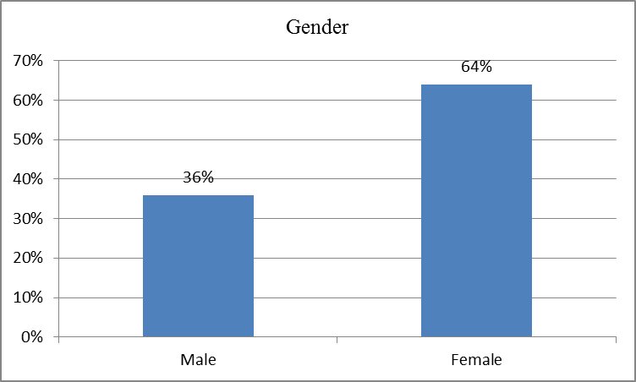
Table 1: Genderof respondents

Age range of the respondents: Regarding the age of the respondents, it has been observed that although respondents were selected randomly, the age groups that are represented in the sample are between 15 and 55 years. This group made up 56% of the respondents. The age group 26 to 35 years takes second place at 40% of the total sample. Respondents within the age groups 36 to 45 and 46 to 55 years made up only 2% of the population. Table 2 below shows the distribution of age in the research sample.

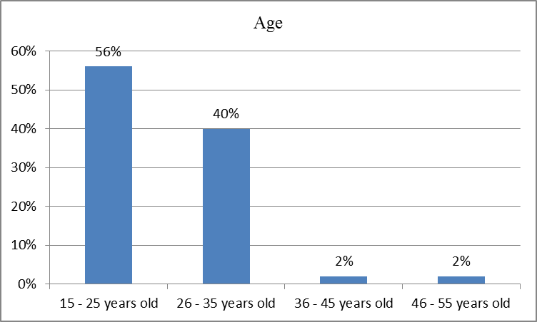
Table 2: Age of respondents
Occupation of the respondents: The questionnaire was answered by respondents of various occupations ranging from students to bankers and government officials. The survey required an informant to indicate whether they were employed or unemployed, specific job titles were asked for and students had the highest number within the sample making up 33% followed by retail and administration both at 18%. Those in the banking industry were labelled as bankers without giving specific job titles and they comprise 13% of the respondents. Educationist and education consultants made up 7% of the respondents while those in the IT industry comprised 4% of the sample. The remaining 6% of the respondents was shared by those who were self-employed, economists and policy analysts who made up 2% each as is shown in the table below.

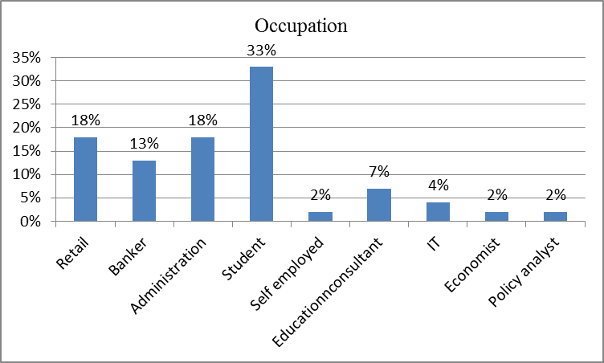
Table 3: Occupation of respondents

The buying power: The survey found out that a huge number of respondents still buy newspapers in their print form while there are those who do not buy newspapers due to various reasons. From the total of 100% of the sample, 87% said they buy the hard copy of local newspapers and only 13% said they do not buy newspapers. These data are represented in the table below.

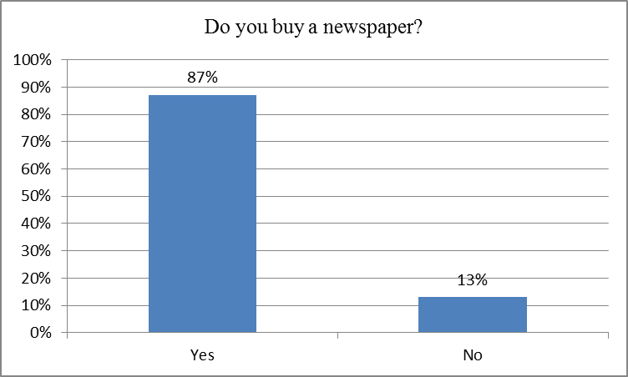
Table 4: The percentage of newspaper buyers and those who do not buy

Buying frequency: The researchers wanted to establish how frequent respondents buy newspapers per week. The highest percentage was that of those who buy a newspaper five times per week which translates to a newspaper per day, at 35 %. This was followed by those who buy a newspaper three times a week who made up 24%. There were also respondents who buy a newspaper two times a week and they made up 20% of the sample. Seventeen percent of the respondents said they buy a newspaper once a week. The smallest percentage was that of respondents who buy newspapers four times per week that comprised the remaining 4% of the sample. The table below shows the distribution of the frequency with which readers buy newspapers.

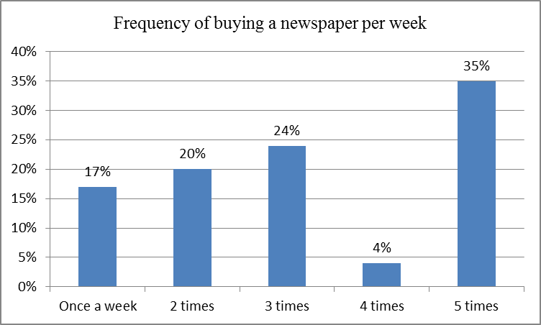
Table 5: Number of times respondents buy a newspaper per week

Newspapers bought regularly: The researcher sought to find out the newspaper that the respondents regularly buy and the majority said they buy the Namibian. A massive 79% buy the Namibian on a regular basis and there is an enormous gap between this figure and the number two newspaper according to the survey, the Republikein with 19% of the respondents saying that is the newspaper they buy regularly. New Era comes third on the list of newspapers with 11% of the readers buying it regularly followed by confidente with 6%, Namibian Sun and the Villager with 4% each. Informante and Windhoek Observer with 2% each. The table below shows the newspapers that the respondents buy regularly.

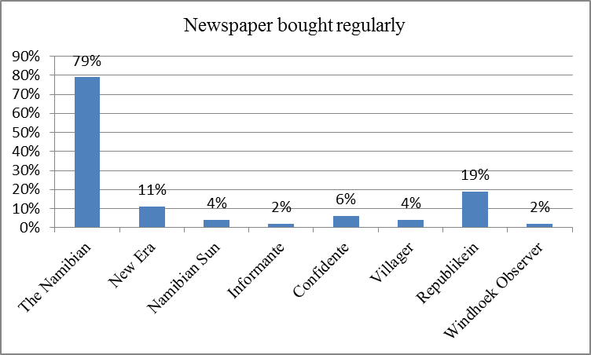
Table 6: Newspapers which respondents regularly buy

Reasons for buying newspaper: The respondents also indicated why they buy newspapers giving reasons such as news, advertisements and other information. The survey showed that 79% of the sample said they buy newspapers to read news that includes business and sports news while 45% are after advertisements, most of them look for vacancies, sales and many other things that are advertised in the newspaper and 2% buy newspapers for notices. These reasons are shown in the table below.

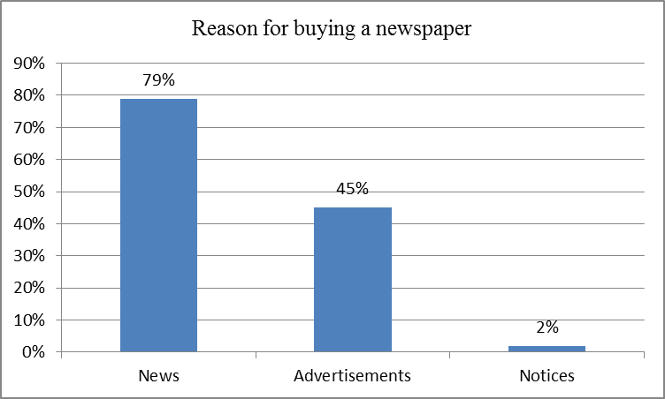
Table 7: Reasons for buying a newspaper

The Impact of digitization
The impact of digitalization is being felt by the Namibian media. Almost all print media establishments are connected to the Internet through their websites and have Facebook and Twitter accounts. Despite the introduction of digitization, the Namibian newspaper industry has not experienced significant drop in readership. At independence in 1991, there were only eight newspapers in Namibia (Mwilima, 1988), but this number has grown to 11 in 2018 (GRN, 2018). There are more newspapers in circulation now than at independence in 1991 and their numbers keeps growing. This shows that the print newspaper industry has not suffered significantly from digitisation of the media. The Editor of the Namibian newspapers noted that “Our printed copy is still increasing in popularity, we continue to print more and more pages and if the printer could allow us, we could increase the size of the newspaper and also the number of copies.”The newspaper prints 35 000 copies between Monday and Thursday and on Fridays, the print run increases 65 000. The newspaper has not observed a decrease in advertisements. However, traditional advertisers such as big companies, no longer place full page advertisements, they take smaller ones and put a link to their websites. The Namibian laws, compel companies to advertise their annual results in the newspapers and this has worked to the advantage of the print media.
“The future is digital, there is no doubt about that because distributing news online is faster and cheaper than through hardcopy.” He noted that producing hard copies is not environmentally friendly due to the number of trees that must be cut to produce paper. I foresee problems for the print media as the internet becomes more widespread and cheaper.” However, the newspaper management is optimistic that digitisation comes with opportunities as the migration to online platforms will reduce the distribution costs. “I believe we are going to see some changes in the next five to ten years. The entire newspaper is uploaded online every morning from 06h00 to 19h30. Throughout the day new news items are also uploaded online. The newspaper has observed significant increase in traffic to the website, but sales of the print newspaper has also increased overtime.
New Era, on the other hand, has embraced digital media and the internet has changed the way the newspaper operates. New Era’s website is constantly updated with links to social media platforms such as Facebook and Twitter. “We actually get more people to buy the paper because of the use of the website and social media,” the newspaper editor observed. Much of the revenue of this newspaper comes from advertising and the circulation which is on the increase even in the face of digital media. Advertising remains the cornerstone of its operations in terms of revenue generation. The increase in advertisement is such that there is an advert almost on each page, sometimes it is compelled to increase the number of pages to accommodate advertisements. The impact of digitization has been observed in the use of news sources. Journalists must now think fast and be creative in using different online sources and must have skills and competency to use multimedia platforms for them to remain relevant in the digital age. Although the Namibian print media expect a major shift in the way it operates, so far the impact of digital media is positive. The opportunitiesbrought by digital media are endless; it cost effective, communication with readers is constant and ongoing. But, the Namibian print media may still be in business for some time to come even in the digital revolution.

- CONCLUSION (10 Bold)
The impact of digitization on the Namibian newspaper industry are positive and negative. With digitization, it is now easier to reach a wider audience, the interaction is fast, instant and continuous and has provided a multiplicity of sources for journalists. The negative impact is that newspaper loses revenue due to drops in circulation as well as the migration of both readers and advertisers to online platforms. Bu the study has shown that the threat of digitization on the Namibian and Newspapers in Namibia is yet to be felt as the circulation of hardcopy newspapers continue to increase. Digitization has brought more opportunities than challenges for the Namibian newspapers industry as the industry continues to thrive due to increasing sales and advertising and that advertisers are still miles away from completely embracing digital media and harnessing the power of the internet. It has also been observed that although there is willingness to migrate to online platforms by readers, factors such as internet connectivity and speed, remain immediate constraints towards full digitization of the newspaper industry.

REFERENCES (10 Bold)
- Mdlongwa, F. (2009).Digital era unleashes ambiguity and uncertainty in doing digital media in Africa prospects, promises and problems. Johannesburg, SA: Konrad-Adenauer-
- Stiftung.
- Namibia Statistics Agency, (2017). Namibia Inter-censal Demographic Survey 2016 Report. Namibia Statistics Agency, Windhoek.
- Osunade, o. (2003). An evaluation of the impact of Internet browsing on students' academic performance at the tertiary level of education in Nigeria. Retrieved from: http://www.rocare.org/smallgrant_nigeria2003.pdf.
- Bell, L.(2009).Newspapers look to digital as print faces challenges. Direct marketing news, March 20, 2009. Retrieved on 8 April 2014 from http://www.dmnews.com/search/Newspapers+look+to+digital+as+print+faces+c challenges/
- Center for Communication and Civic Engagement (,n.d.). The Internet’s Impact on News Media. Retrieved from http://voices.yahoo.com/internet-impact-top-10-newspapers- 2002-6152106.html?cat=3
- Otieno, C. (2009). Mobile media in Africa. In Mdlongwa, F. (Ed), Doing digital in Africa: prospects, promises and problems (pp. 16). Johannesburg, SA: Konrand-Andenaur-Stiftung.
- Gates, D. (2002).Newspapers in the Digital Age. Online journalism review. Retrieve on 8 April 2014 from http://annenberg.usc.edu/search.aspx?query=Newspapers in the Digital Age
- UNESCO (1997) World Communication Report;The media and the challenge of the new technology.Paris.UNESCO Publishing Validity and Reliability (n.d.). Retrieved fromwww.stat.purdue.edu/.../VALIDITY%20AND%20RELIABILITY.doc
- Peeter, M.(2009).Digital Newspapers and Magazines: Changing Trends with Changing Time. Retrieved on 8 April 2014 fromhttp://www.articlesbase.com/r=abc.
- PewResearchCenter for the People and the Press. (2012). In Changing News Landscape, Even Television is Vulnerable. Retrieved from http://www.peoplepress.org/2012/
- Internet World Stats (2017). Internet Penetration in Africa. Retrieved from https://www.internetworldstats.com/stats1.htm
- Namibia Population (2018). Country meters.info. Retrieved from http://countrymeters.info/en/Namibia
Fred J. Mwilima"A Critical Discourse Analysis on the Impact of Digitization on the Operations of the Namibian Print Media: A Case Study of Two Print Newspapers.”International Journal of Humanities and Social Science Invention(IJHSSI), vol. 07, no. 8, 2018, pp. 20-26.

